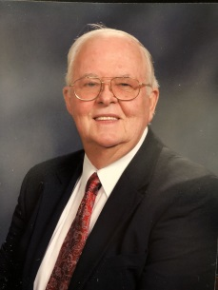
Dean Wirtz, 82, of Lexington, died Friday (Feb. 23, 2018) at Advocate BroMenn Medical Center, Normal.
Funeral Services will be 11 a.m. Thursday at First United Methodist Church, Lexington, with the Rev. Garry Gromely officiating. Burial will follow in Evergreen Cemetery, Bloomington. Visitation will be from 4 to 7 p.m. Wednesday at Calvert–Johnson & Musselman Memorial Home, Lexington, and for one hour prior to services Thursday at the church. Memorials may be made to his church or the Community Cancer Center, Normal.
Dean was born Sept. 28, 1935, in Gillette Grove, Iowa, a son of Raymond and Mildred Chalafant Wirtz. He married Ardis E. Clear on Sept. 28, 1957. She preceded him in death on April 19, 2008. He later married Shirley A. Scarbeary on Aug. 10, 2012. She survives.
Also surviving are his children, Barry (Melody) Wirtz, Bloomington, and Nancy (Dan) Simmons, Stanford; two step-children, Jody (Belinda) Williams, Lexington and Jer Ri (Don) Panek, Yorkville; eight grandchildren, Nathan, Jarad and Bryant Simmons, Joshua and Ben Wirtz, Katie and Ryan English and Kandi Simmons; 10 great-grandchildren; a brother, Cecil (Landa) Wirtz, Orland Park, Kan., and a sister-in-law, Pat Wirtz, Wheaton.
He was preceded in death by his parents; his step-mother, Verda Wirtz; and two brothers, John and Eldon Wirtz.
He was a member of the First United Methodist Church in Lexington and was a member of the Bloomington Kiwanis Club.
He worked for NICOR Gas for over 25 years.

